PESTICIDE MINIBULKS
Resources

If you store bulk amounts of pesticide or fertilizer over 30 days, you must register your facility with OISC at no charge. The form (Pesticide or Fertilizer) is available at OISC’s website: https://www.oisc.purdue.edu/fertilizer/pdf/registration_bulk_storage_facilities_fert_pest.pdf

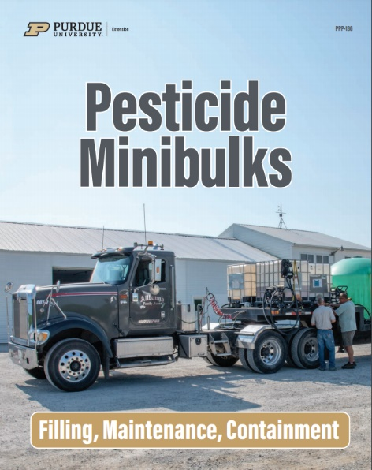
The Pesticide Stewardship Alliance website has resources specifically for Mini Bulk / IBC. The site includes lists of where to recycle old containers: https://tpsalliance.org/

Purdue publication PPP-136 is available for free online! https://ppp.purdue.edu/wp-content/uploads/2020/09/PPP-136.pdf

Office of Indiana State Chemist
Joe Becovitz
Telephone: 765-494-1589
E-mail: becovitz@purdue.edu
